
POROČILO ANALIZE HITROSTI Z
RADARSKO TABLO MHP50
OBDOBJE: 01.04.2025 00:00 - 30.04.2025 23:59
LOKACIJA: Destrnik - PLACAR

Kazalo
Lokacija in način meritev
Število prevozov
Hitrosti
Percentili hitrosti
Hitrostni razredi
Dnevne obremenitve
Tabela rezultatov

Lokacija in način meritev
Lokacija: Destrnik - PLACAR (46.454492,15.892852)
Radarska naprava: MHP50
Serijska številka: 1211222
Način meritve:
Podatki so bili zajeti s preventivno radarsko tablo MHP50. Omejitev hitrosti na lokaciji je 70 km/h. Analiza je narejena za obdobje od 01.04.2025 00:00 do 30.04.2025 23:59.
V nadaljevanju je v grafih prikazano število vozil oz. prometna obremenitev, povprečna in maksimalna hitrost, percentilna vrednost hitrosti ter izračun frekvence glede na hitrostne razrede (1-10 km/h, 11-20 km/h, 21-30 km/h, 31-40 km/h, 41-50 km/h, 51-60 km/h, 61-70 km/h, 71-80 km/h, 81-90 km/h). Frekvenca je prikazana s stolpičnim diagramom. Sledi še tabela z rezultati za posamezen dan za celotno obdobje merjenja.


Število prevozov
V obdobju od 01.04.2025 00:00 do 30.04.2025 23:59 je bilo zabeleženih 55.509 meritev oziroma 24.883 prevozov (en prevoz je lahko izmerjen večkrat).
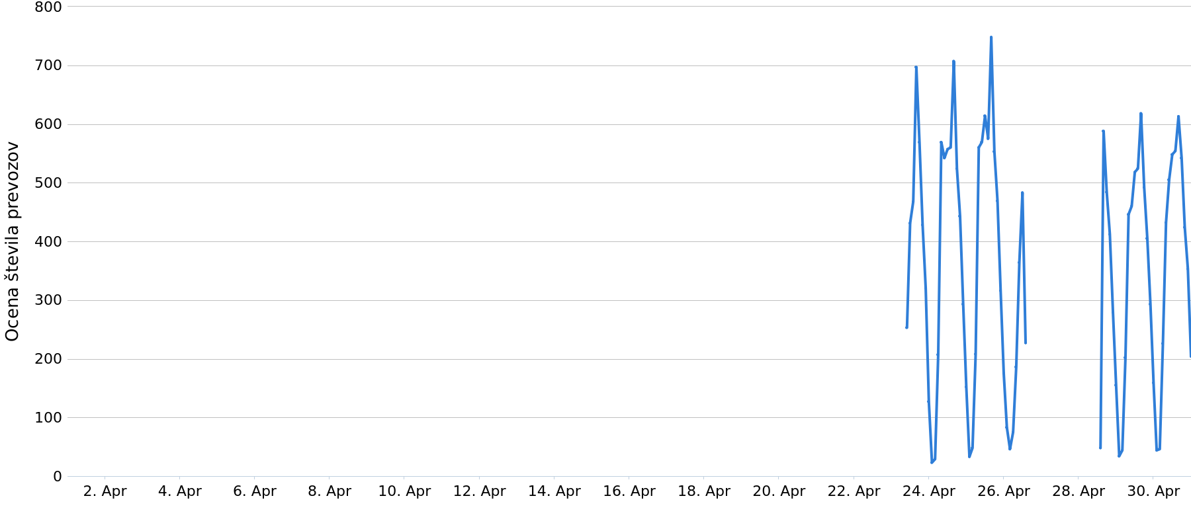
Graf 1: Ocena števila prevozov v obdobju od 01.04.2025 00:00 do 30.04.2025 23:59

Hitrosti
Spodnji graf prikazuje povprečne in maksimalne hitrosti za obdobje od 01.04.2025 00:00 do 30.04.2025 23:59. Povprečna hitrost vozil je 61 km/h, najvišja izmerjena pa 118 km/h.
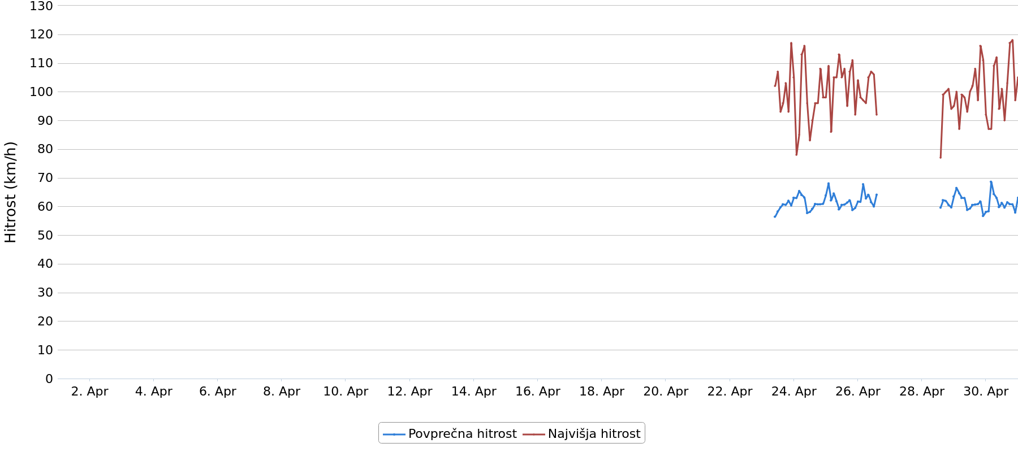
Graf 2: Povprečne in maksimalne hitrosti v obdobju od 01.04.2025 00:00 do 30.04.2025 23:59

Percentili hitrosti
V celotnem obdobju meritev je 85% vozil vozilo do hitrosti največ 71 km/h, 50% vozil je vozilo do hitrosti 61 km/h in 30% vozil je vozilo do hitrosti 56 km/h.
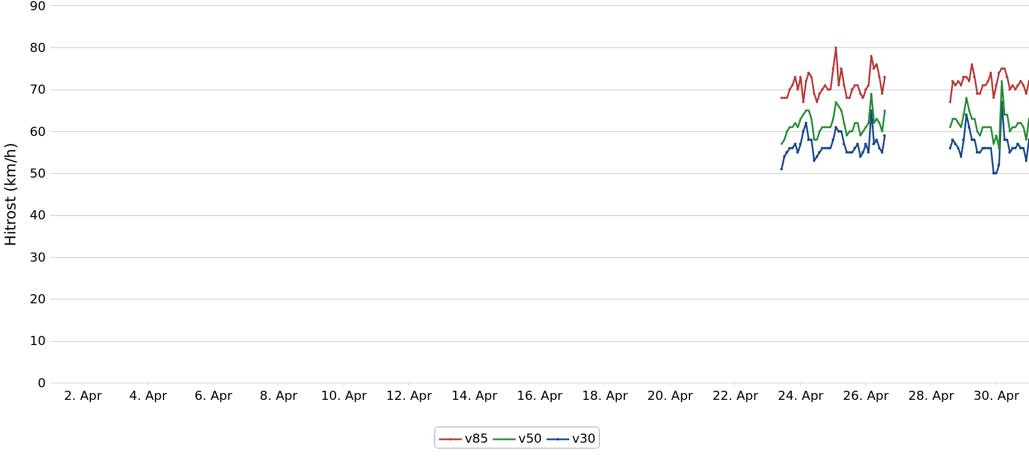
Graf 3: Hitrost do katere je vozil določen odstotek vozil v obdobju od 01.04.2025 00:00 do 30.04.2025 23:59

Hitrostni razredi
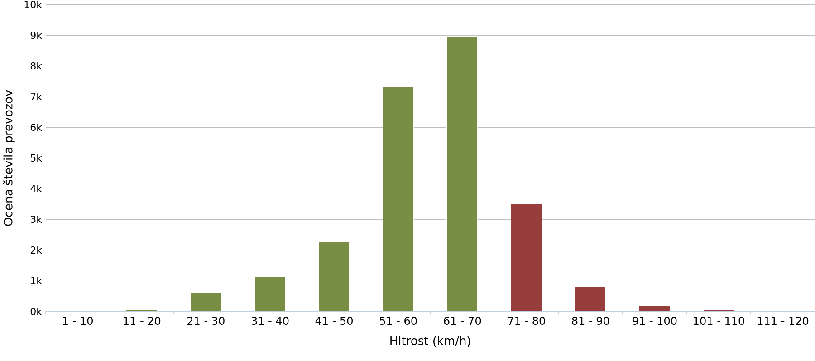
Graf 4: Porazdelitev izmerjenih hitrosti v obdobju od 01.04.2025 00:00 do 30.04.2025 23:59

 | 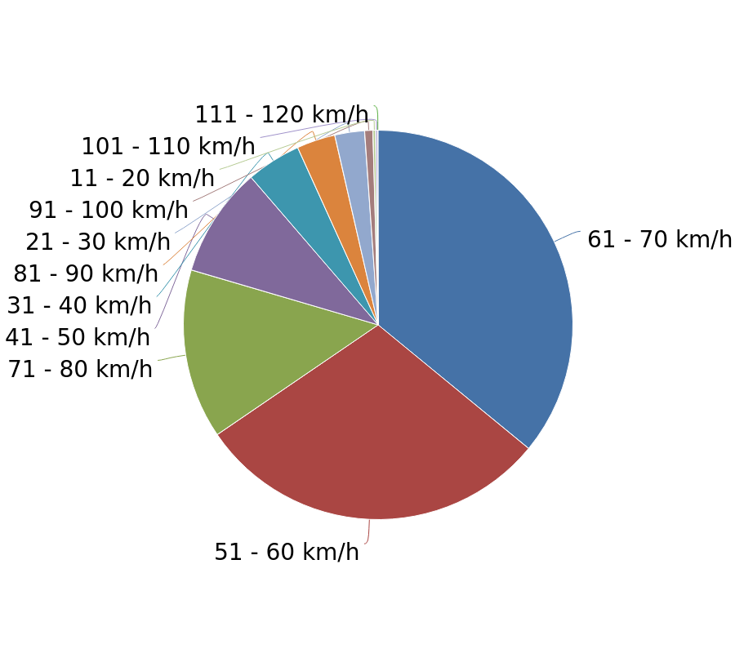  Graf 8: Porazdelitev izmerjenih hitrosti v obdobju od 01.04.2025 00:00 do 30.04.2025 23:59
  Hitrost km/h | Št. meritev | Ocena št. prevozov | %
  1 - 10 | 0 | 0 | 0
  11 - 20 | 70 | 57 | 0
  21 - 30 | 1.150 | 612 | 2
  31 - 40 | 2.302 | 1.130 | 5
  41 - 50 | 4.964 | 2.273 | 9
  51 - 60 | 17.014 | 7.345 | 30
  61 - 70 | 20.537 | 8.946 | 36
  71 - 80 | 7.683 | 3.505 | 14
  81 - 90 | 1.462 | 796 | 3
  91 - 100 | 265 | 171 | 1
  101 - 110 | 48 | 37 | 0
  111 - 120 | 14 | 11 | 0
  Skupno | 55.509 | 24.883 | 100

Dnevne obremenitve
Datum | Št. meritev | Ocena št. prevozov
23.04.2025 | 7.485 | 3.291
24.04.2025 | 10.370 | 4.600
25.04.2025 | 10.893 | 4.867
26.04.2025 | 3.138 | 1.473
27.04.2025 | 0 | 0
28.04.2025 | 4.307 | 1.961
29.04.2025 | 9.373 | 4.197
30.04.2025 | 9.943 | 4.494
Skupno | 55.509 | 24.883

Tabela rezultatov
Datum | Št. meritev | Ocena št. prevozov | Povprečna hitrost | Najvišja hitrost | V85 | V50 | V30
23.04.2025 10:00 | 614 | 253 | 56 | 102 | 68 | 58 | 52
23.04.2025 11:00 | 412 | 170 | 56 | 107 | 67 | 58 | 52
23.04.2025 12:00 | 599 | 261 | 59 | 94 | 69 | 59 | 55
23.04.2025 13:00 | 517 | 223 | 59 | 82 | 69 | 60 | 55
23.04.2025 14:00 | 563 | 245 | 60 | 93 | 69 | 60 | 56
23.04.2025 15:00 | 806 | 346 | 59 | 94 | 70 | 61 | 55
23.04.2025 16:00 | 777 | 351 | 62 | 96 | 71 | 63 | 58
23.04.2025 17:00 | 714 | 308 | 59 | 103 | 70 | 61 | 55
23.04.2025 18:00 | 573 | 261 | 62 | 90 | 73 | 63 | 58
23.04.2025 19:00 | 463 | 214 | 63 | 92 | 75 | 64 | 60
23.04.2025 20:00 | 477 | 214 | 60 | 93 | 72 | 61 | 56
23.04.2025 21:00 | 459 | 198 | 59 | 83 | 69 | 60 | 55
23.04.2025 22:00 | 255 | 122 | 63 | 117 | 73 | 63 | 57
23.04.2025 23:00 | 203 | 98 | 63 | 105 | 73 | 64 | 57
24.04.2025 00:00 | 56 | 29 | 63 | 83 | 72 | 63 | 60
24.04.2025 01:00 | 31 | 16 | 64 | 78 | 69 | 66 | 61
24.04.2025 02:00 | 15 | 7 | 61 | 70 | 64 | 62 | 61
24.04.2025 03:00 | 4 | 2 | 39 | 41 | 41 | 40 | 39
24.04.2025 04:00 | 46 | 27 | 67 | 85 | 75 | 67 | 64
24.04.2025 05:00 | 91 | 50 | 63 | 113 | 73 | 64 | 57
24.04.2025 06:00 | 318 | 157 | 64 | 93 | 76 | 66 | 59
24.04.2025 07:00 | 599 | 284 | 65 | 116 | 77 | 66 | 61
24.04.2025 08:00 | 647 | 285 | 61 | 98 | 70 | 62 | 57
24.04.2025 09:00 | 577 | 245 | 59 | 92 | 70 | 60 | 54
24.04.2025 10:00 | 715 | 297 | 57 | 96 | 69 | 58 | 53
24.04.2025 11:00 | 656 | 278 | 58 | 83 | 68 | 59 | 54
24.04.2025 12:00 | 663 | 279 | 58 | 83 | 67 | 58 | 54
24.04.2025 13:00 | 645 | 279 | 59 | 85 | 69 | 60 | 55
24.04.2025 14:00 | 653 | 281 | 59 | 90 | 70 | 60 | 55
24.04.2025 15:00 | 783 | 339 | 60 | 89 | 70 | 61 | 55
24.04.2025 16:00 | 823 | 368 | 62 | 96 | 71 | 63 | 58
24.04.2025 17:00 | 704 | 310 | 61 | 93 | 71 | 62 | 56
24.04.2025 18:00 | 481 | 214 | 61 | 96 | 72 | 60 | 56
24.04.2025 19:00 | 497 | 224 | 61 | 108 | 71 | 62 | 58
24.04.2025 20:00 | 495 | 219 | 60 | 98 | 70 | 62 | 56
24.04.2025 21:00 | 433 | 192 | 60 | 98 | 69 | 60 | 56
24.04.2025 22:00 | 200 | 101 | 63 | 94 | 74 | 63 | 57
24.04.2025 23:00 | 199 | 97 | 65 | 93 | 76 | 65 | 60
25.04.2025 00:00 | 104 | 55 | 62 | 98 | 73 | 62 | 55
25.04.2025 01:00 | 37 | 23 | 69 | 109 | 81 | 69 | 63
25.04.2025 02:00 | 16 | 10 | 66 | 90 | 78 | 63 | 59
25.04.2025 03:00 | 28 | 16 | 66 | 78 | 71 | 69 | 62
25.04.2025 04:00 | 63 | 32 | 60 | 86 | 72 | 65 | 60
25.04.2025 05:00 | 87 | 47 | 67 | 89 | 74 | 69 | 64
25.04.2025 06:00 | 326 | 161 | 64 | 105 | 76 | 65 | 59
25.04.2025 07:00 | 595 | 270 | 62 | 105 | 73 | 64 | 58
25.04.2025 08:00 | 653 | 290 | 61 | 103 | 70 | 62 | 58
25.04.2025 09:00 | 658 | 285 | 59 | 113 | 68 | 61 | 56
25.04.2025 10:00 | 665 | 284 | 59 | 86 | 68 | 59 | 55
25.04.2025 11:00 | 647 | 282 | 60 | 94 | 68 | 61 | 56
25.04.2025 12:00 | 749 | 332 | 61 | 105 | 69 | 61 | 56
25.04.2025 13:00 | 651 | 282 | 59 | 95 | 69 | 60 | 55
25.04.2025 14:00 | 652 | 293 | 62 | 108 | 72 | 62 | 57
25.04.2025 15:00 | 860 | 376 | 60 | 93 | 71 | 61 | 55
25.04.2025 16:00 | 824 | 372 | 62 | 95 | 73 | 64 | 58
25.04.2025 17:00 | 687 | 312 | 63 | 96 | 71 | 64 | 59
25.04.2025 18:00 | 542 | 241 | 61 | 107 | 72 | 62 | 56
25.04.2025 19:00 | 598 | 262 | 59 | 111 | 70 | 60 | 55
25.04.2025 20:00 | 485 | 207 | 58 | 105 | 69 | 59 | 53
25.04.2025 21:00 | 423 | 184 | 59 | 92 | 68 | 59 | 55
25.04.2025 22:00 | 289 | 132 | 61 | 92 | 69 | 61 | 56
25.04.2025 23:00 | 255 | 121 | 61 | 104 | 71 | 61 | 57
26.04.2025 00:00 | 108 | 54 | 63 | 81 | 69 | 64 | 60
26.04.2025 01:00 | 71 | 38 | 62 | 98 | 73 | 62 | 56
26.04.2025 02:00 | 90 | 45 | 61 | 79 | 70 | 63 | 55
26.04.2025 03:00 | 49 | 29 | 67 | 85 | 75 | 69 | 65
26.04.2025 04:00 | 26 | 17 | 68 | 97 | 86 | 71 | 66
26.04.2025 05:00 | 46 | 25 | 60 | 86 | 70 | 61 | 56
26.04.2025 06:00 | 92 | 50 | 64 | 96 | 78 | 64 | 59
26.04.2025 07:00 | 160 | 81 | 64 | 94 | 76 | 64 | 59
26.04.2025 08:00 | 213 | 105 | 64 | 105 | 76 | 64 | 58
26.04.2025 09:00 | 310 | 146 | 61 | 107 | 74 | 63 | 55
26.04.2025 10:00 | 481 | 218 | 62 | 98 | 73 | 62 | 57
26.04.2025 11:00 | 505 | 218 | 58 | 106 | 69 | 59 | 54
26.04.2025 12:00 | 591 | 265 | 61 | 102 | 70 | 62 | 58
26.04.2025 13:00 | 487 | 227 | 64 | 92 | 73 | 65 | 60
26.04.2025 14:00 | 0 | 0 | 0 | 0 | 0 | 0 | 0
26.04.2025 15:00 | 0 | 0 | 0 | 0 | 0 | 0 | 0
26.04.2025 16:00 | 0 | 0 | 0 | 0 | 0 | 0 | 0
26.04.2025 17:00 | 0 | 0 | 0 | 0 | 0 | 0 | 0
26.04.2025 18:00 | 0 | 0 | 0 | 0 | 0 | 0 | 0
26.04.2025 19:00 | 0 | 0 | 0 | 0 | 0 | 0 | 0
26.04.2025 20:00 | 0 | 0 | 0 | 0 | 0 | 0 | 0
26.04.2025 21:00 | 0 | 0 | 0 | 0 | 0 | 0 | 0
26.04.2025 22:00 | 0 | 0 | 0 | 0 | 0 | 0 | 0
26.04.2025 23:00 | 0 | 0 | 0 | 0 | 0 | 0 | 0
27.04.2025 00:00 | 0 | 0 | 0 | 0 | 0 | 0 | 0
27.04.2025 01:00 | 0 | 0 | 0 | 0 | 0 | 0 | 0
27.04.2025 02:00 | 0 | 0 | 0 | 0 | 0 | 0 | 0
27.04.2025 03:00 | 0 | 0 | 0 | 0 | 0 | 0 | 0
27.04.2025 04:00 | 0 | 0 | 0 | 0 | 0 | 0 | 0
27.04.2025 05:00 | 0 | 0 | 0 | 0 | 0 | 0 | 0
27.04.2025 06:00 | 0 | 0 | 0 | 0 | 0 | 0 | 0
27.04.2025 07:00 | 0 | 0 | 0 | 0 | 0 | 0 | 0
27.04.2025 08:00 | 0 | 0 | 0 | 0 | 0 | 0 | 0
27.04.2025 09:00 | 0 | 0 | 0 | 0 | 0 | 0 | 0
27.04.2025 10:00 | 0 | 0 | 0 | 0 | 0 | 0 | 0
27.04.2025 11:00 | 0 | 0 | 0 | 0 | 0 | 0 | 0
27.04.2025 12:00 | 0 | 0 | 0 | 0 | 0 | 0 | 0
27.04.2025 13:00 | 0 | 0 | 0 | 0 | 0 | 0 | 0
27.04.2025 14:00 | 0 | 0 | 0 | 0 | 0 | 0 | 0
27.04.2025 15:00 | 0 | 0 | 0 | 0 | 0 | 0 | 0
27.04.2025 16:00 | 0 | 0 | 0 | 0 | 0 | 0 | 0
27.04.2025 17:00 | 0 | 0 | 0 | 0 | 0 | 0 | 0
27.04.2025 18:00 | 0 | 0 | 0 | 0 | 0 | 0 | 0
27.04.2025 19:00 | 0 | 0 | 0 | 0 | 0 | 0 | 0
27.04.2025 20:00 | 0 | 0 | 0 | 0 | 0 | 0 | 0
27.04.2025 21:00 | 0 | 0 | 0 | 0 | 0 | 0 | 0
27.04.2025 22:00 | 0 | 0 | 0 | 0 | 0 | 0 | 0
27.04.2025 23:00 | 0 | 0 | 0 | 0 | 0 | 0 | 0
28.04.2025 00:00 | 0 | 0 | 0 | 0 | 0 | 0 | 0
28.04.2025 01:00 | 0 | 0 | 0 | 0 | 0 | 0 | 0
28.04.2025 02:00 | 0 | 0 | 0 | 0 | 0 | 0 | 0
28.04.2025 03:00 | 0 | 0 | 0 | 0 | 0 | 0 | 0
28.04.2025 04:00 | 0 | 0 | 0 | 0 | 0 | 0 | 0
28.04.2025 05:00 | 0 | 0 | 0 | 0 | 0 | 0 | 0
28.04.2025 06:00 | 0 | 0 | 0 | 0 | 0 | 0 | 0
28.04.2025 07:00 | 0 | 0 | 0 | 0 | 0 | 0 | 0
28.04.2025 08:00 | 0 | 0 | 0 | 0 | 0 | 0 | 0
28.04.2025 09:00 | 0 | 0 | 0 | 0 | 0 | 0 | 0
28.04.2025 10:00 | 0 | 0 | 0 | 0 | 0 | 0 | 0
28.04.2025 11:00 | 0 | 0 | 0 | 0 | 0 | 0 | 0
28.04.2025 12:00 | 0 | 0 | 0 | 0 | 0 | 0 | 0
28.04.2025 14:00 | 101 | 48 | 60 | 77 | 67 | 62 | 56
28.04.2025 15:00 | 605 | 271 | 62 | 99 | 72 | 62 | 57
28.04.2025 16:00 | 698 | 317 | 63 | 90 | 73 | 64 | 60
28.04.2025 17:00 | 592 | 265 | 61 | 93 | 71 | 62 | 57
28.04.2025 18:00 | 472 | 219 | 63 | 100 | 73 | 64 | 58
28.04.2025 19:00 | 486 | 219 | 61 | 101 | 74 | 64 | 57
28.04.2025 20:00 | 429 | 193 | 60 | 98 | 71 | 62 | 57
28.04.2025 21:00 | 424 | 186 | 58 | 91 | 70 | 60 | 54
28.04.2025 22:00 | 191 | 93 | 62 | 94 | 73 | 64 | 56
28.04.2025 23:00 | 180 | 87 | 63 | 95 | 74 | 64 | 58
29.04.2025 00:00 | 138 | 68 | 64 | 83 | 74 | 65 | 60
29.04.2025 01:00 | 27 | 16 | 68 | 100 | 76 | 70 | 66
29.04.2025 02:00 | 32 | 18 | 65 | 79 | 72 | 68 | 64
29.04.2025 03:00 | 16 | 10 | 60 | 77 | 65 | 63 | 59
29.04.2025 04:00 | 63 | 34 | 66 | 87 | 75 | 66 | 62
29.04.2025 05:00 | 98 | 51 | 65 | 99 | 78 | 62 | 60
29.04.2025 06:00 | 320 | 151 | 62 | 93 | 76 | 64 | 58
29.04.2025 07:00 | 462 | 221 | 65 | 98 | 75 | 66 | 62
29.04.2025 08:00 | 509 | 225 | 61 | 90 | 72 | 61 | 56
29.04.2025 09:00 | 521 | 228 | 59 | 93 | 71 | 61 | 56
29.04.2025 10:00 | 544 | 232 | 58 | 83 | 69 | 61 | 55
29.04.2025 11:00 | 627 | 269 | 59 | 83 | 68 | 59 | 55
29.04.2025 12:00 | 561 | 249 | 60 | 100 | 70 | 60 | 55
29.04.2025 13:00 | 548 | 236 | 59 | 95 | 69 | 60 | 55
29.04.2025 14:00 | 635 | 288 | 62 | 102 | 73 | 63 | 58
29.04.2025 15:00 | 715 | 320 | 62 | 108 | 72 | 63 | 57
29.04.2025 16:00 | 690 | 298 | 59 | 91 | 71 | 61 | 56
29.04.2025 17:00 | 548 | 243 | 60 | 89 | 72 | 62 | 56
29.04.2025 18:00 | 552 | 249 | 62 | 97 | 73 | 62 | 57
29.04.2025 19:00 | 461 | 211 | 61 | 102 | 75 | 62 | 56
29.04.2025 20:00 | 417 | 194 | 62 | 116 | 74 | 62 | 57
29.04.2025 21:00 | 346 | 151 | 57 | 111 | 69 | 58 | 51
29.04.2025 22:00 | 334 | 142 | 56 | 100 | 69 | 57 | 50
29.04.2025 23:00 | 230 | 104 | 58 | 92 | 72 | 60 | 51
30.04.2025 00:00 | 113 | 55 | 57 | 88 | 71 | 59 | 48
30.04.2025 01:00 | 53 | 25 | 53 | 87 | 75 | 49 | 43
30.04.2025 02:00 | 29 | 19 | 66 | 86 | 73 | 67 | 66
30.04.2025 03:00 | 18 | 12 | 78 | 83 | 82 | 80 | 78
30.04.2025 04:00 | 58 | 34 | 65 | 87 | 73 | 70 | 63
30.04.2025 05:00 | 153 | 78 | 65 | 109 | 77 | 64 | 57
30.04.2025 06:00 | 306 | 148 | 64 | 86 | 75 | 65 | 60
30.04.2025 07:00 | 452 | 219 | 65 | 112 | 76 | 67 | 61
30.04.2025 08:00 | 478 | 213 | 60 | 109 | 71 | 61 | 57
30.04.2025 09:00 | 510 | 227 | 61 | 91 | 72 | 62 | 56
30.04.2025 10:00 | 650 | 278 | 59 | 94 | 70 | 59 | 54
30.04.2025 11:00 | 683 | 300 | 61 | 95 | 70 | 61 | 56
30.04.2025 12:00 | 537 | 248 | 62 | 101 | 73 | 62 | 58
30.04.2025 13:00 | 659 | 285 | 60 | 90 | 70 | 60 | 56
30.04.2025 14:00 | 619 | 269 | 60 | 90 | 70 | 62 | 56
30.04.2025 15:00 | 702 | 318 | 62 | 103 | 72 | 62 | 58
30.04.2025 16:00 | 660 | 295 | 61 | 97 | 71 | 63 | 58
30.04.2025 17:00 | 618 | 275 | 60 | 103 | 72 | 61 | 56
30.04.2025 18:00 | 592 | 267 | 61 | 117 | 73 | 63 | 57
30.04.2025 19:00 | 556 | 250 | 61 | 118 | 72 | 62 | 56
30.04.2025 20:00 | 389 | 174 | 60 | 88 | 71 | 62 | 56
30.04.2025 21:00 | 438 | 192 | 58 | 97 | 70 | 59 | 53
30.04.2025 22:00 | 367 | 161 | 58 | 93 | 69 | 59 | 55
30.04.2025 23:00 | 273 | 136 | 64 | 105 | 74 | 64 | 60
01.05.2025 00:00 | 138 | 68 | 60 | 93 | 71 | 61 | 56
Skupno | 55.509 | 24.883 | 61 | 118 | 71 | 61 | 56

