UNITED STATES OF EUROPE
Town twinning Municipality of Bled (Slovenia) and Municipality of Subotica (Serbia)
Bled, 12th - 13th April 2018
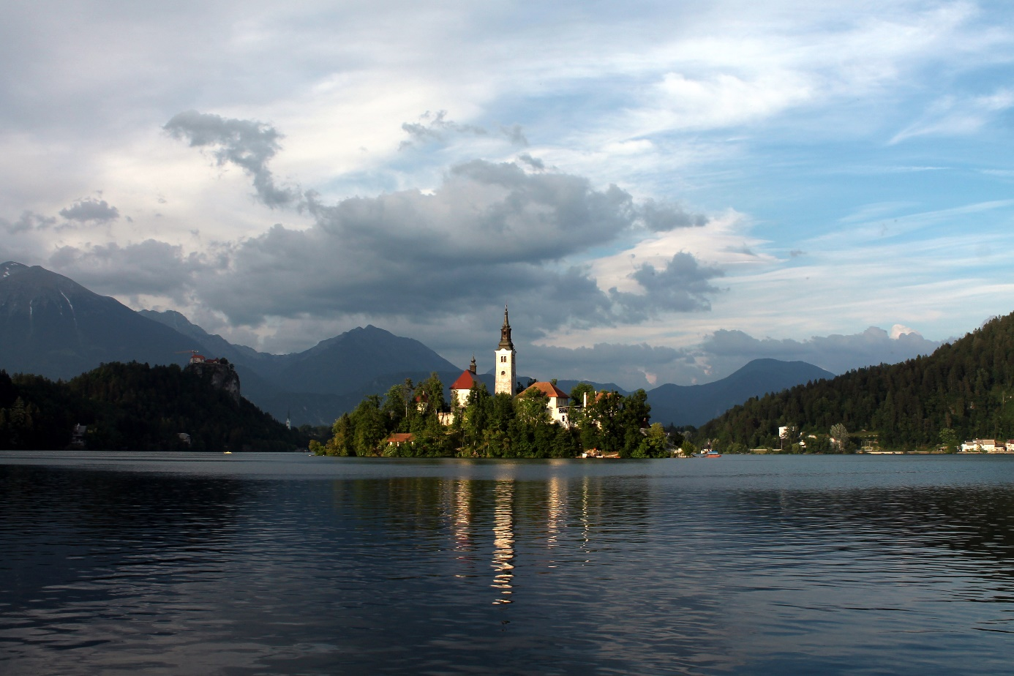

PROGRAM / PROGRAMME:
DAY 1 – 12th April 2018
DOGODEK 1 / EVENT 1 - HOTEL KRIM
18:00 Janez Fajfar: Uvodni pozdrav župana in slavnostna otvoritev projekta / Reception of a mayor and the opening of the event
Franc Bogovič (Evropski poslanec) / Member of the European Parliament): EU kot svetovni akter / EU as world actor
Večerja / Dinner

DAY 2 – 13th April 2018
DOGODEK 2 / EVENT 2 - FESTIVALNA DVORANA BLED / FESTIVAL HALL BLED
9:00 – 9:30 Registracije / Registrations
9:30 – 10:30 Kulturni nastopi otrok in mladine iz Subotice in Bleda – prikaz raznolikosti med narodi. / Presentation of culture from children from Subotica and Bled - view of the diversity between nations.
- Dejan Anđelović - poruri na fruli
- Muzički atelje "Iskon etno'' - ,,Da sam izvor voda ladna'' (akapela)
- Muzički atelje "Iskon etno'' - ''Kosovski božuri''
- Muzički atelje "Iskon etno''
- Program OŠ Bled
- Predstavitev obeh mest
10:30 – 11:00 Odmor s kavo in prigrizkom / Coffe break with snack
11:00 – 11:30 Panel: Migrantska problematika kot sprožilec evroskepticizma / Panel: Problems of migration as a trigger of euroscepsis
    - G. Ilija Đukanović: Vpliv migracij na lokalno skupnost in turizem / Impact of migration on local community and tourism
    - G. Matjaž Berčon: Turisti – sodobni migranti? / Tourists – modern migrants?
11:30 – 12:30 Diskusija: Evropa pred propadom ali vzponom? / Discussion: Europe before rise or fall?
11:00 – 12:30 Delavnici: Participacija civilne družbe za boljši EU / Workshops: Participation of civil society for better EU
- Multikulturnost v mojem mestu / Multiculturalism in my town
- Šolski sistem v moji državi / School system in my country
12:30 – 13:00 Predstavitev zaključkov diskusije in delavnic / Presentation of discussion and workshops
13:00 – 15:00 Odmor in kosilo v hotelu / Break and lunch time at hotel
DOGODEK 3 / EVENT 3 - BLEJSKI GRAD / CASTLE OF BLED
15:00 – 18:00 Ogled Blejskega gradu in debata z EU komisarko Violeto Bulc: EU kot konfederacija / Visiting of Castle of Bled and discussion with EU comissary Violeta Bulc: EU as confederation
Delavnica: Kakšna naj bi bila EU v prihodnosti skozi oči otrok / Workshop: What should be the EU in the future through the eyes of the children
18:30 Večerja v hotelu / Dinner at hotel

